**ANONYMOUS SCRIPT**

**DATE:** 27.07.2022

**AUTHOR:** Liza Kortiak

**APPLICATION:** BlogEngine.NET.3.2

**ENVIRONMENT:** Local Machine

**CONFIGURATION:**

**Prerequisites:**

* Generated 100 posts
* Generated 1000 posts

**GOALS**

* Get an experience of smooth update of the script according to new requirements and cases
* Get an experience in regression testing (like after new version uploaded)
* Get an experience in volume testing
* Improve skills in comparison and analysis

**SCRIPT**

Home Page: 15%

2. Open Random Date: 10%

3. Open Predefined Date: 30%

4. Search by Name: 30%

5. Open Large Calendar: 10%

6. Open Contacts: 5%

Open Random page (yes/no):50% / 50%

Open post (yes/no):80% / 20%

Random or First (yes/no):65% / 35%

Comment (yes/no):20% / 80%

**TESTS**

* 1. **SMOKE**

Ramp-up period = 10s

Number of users = 1

Loop Count = 10

* 1. **CAPACITY**
* **Posts: 100**

**Task 3**

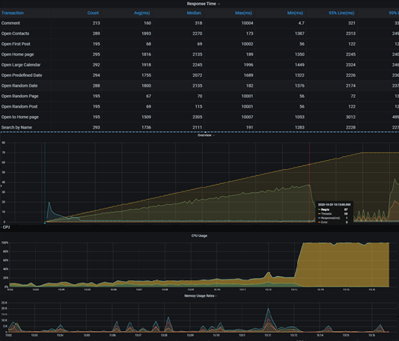

**Resutl: saturation** **point** =**58**

**Task 6**

**Result: saturation** **point** =**49**

**Posts: 1000**

**Task3**

Ramp-up period=10s

Number of Threads =65

Duration= 800

Loop Count=60

**Result: saturation** **point** =**52**

**Task 6**

**Result:** **saturation** **point** =**51**

**Conclusion**

Base on above test data

For task 6 100 and 1000: there are not so much difference while running tests with bigger volume

The system capacity differs while running small volume.